**Solution to the Exercise:**

1. Write a java program using Google App Engine for checking entered number is Odd or Even.

# Project Explorer is as follows –

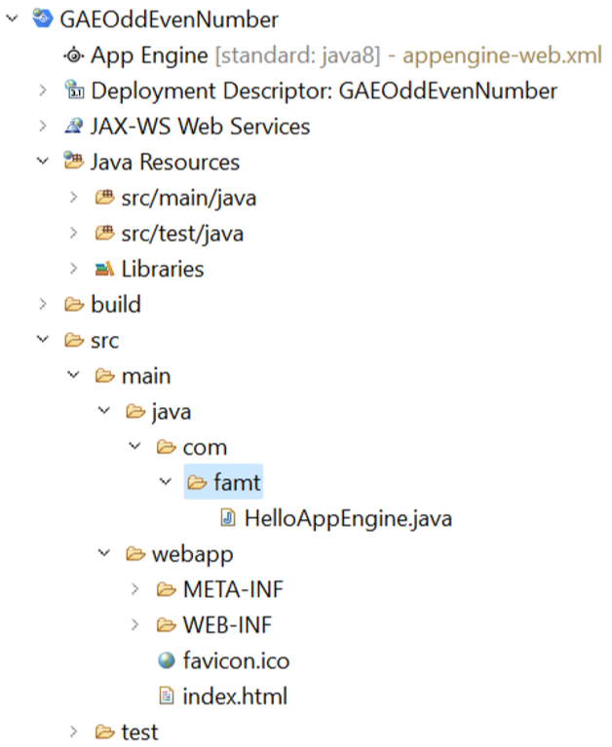

# Code for index.html –

<!DOCTYPE html>

<html xmlns=*"http://www.w3.org/1999/xhtml"* lang=*"en"*>

<head>

<meta http-equiv=*"content-type"* content=*"application/xhtml+xml; charset=UTF-8"* />

<title>Odd Even Number Test</title>

</head>

<body>

<h1>Welcome to Odd Even Number Test Page</h1>

<form method=*"get"* action=*"/hello"*>

Enter a Number <input type=*"text"* name=*"num"*>

<button>Submit</button>

</form>

</body>

</html>

# Code for HelloAppEngine.java – **package** com.famt;

**import** java.io.IOException;

**import** javax.servlet.annotation.WebServlet; **import** javax.servlet.http.HttpServlet; **import** javax.servlet.http.HttpServletRequest; **import** javax.servlet.http.HttpServletResponse;

@WebServlet(

name = "HelloAppEngine", urlPatterns = {"/hello"}

)

**public** **class** HelloAppEngine **extends** HttpServlet { **private** **static** **final** **long** ***serialVersionUID*** = 1L;

@Override

**public** **void** doGet(HttpServletRequest request, HttpServletResponse response) **throws** IOException {

response.setContentType("text/plain"); response.setCharacterEncoding("UTF-8");

String param = request.getParameter("num");

response.getWriter().print(param);

**int** testNum = Integer.*parseInt*(param);

**if**(testNum%2 == 0)

response.getWriter().print(" Number is Even...."); **else**

response.getWriter().print(" Number is Odd....");

}

}

# Output of the Program –

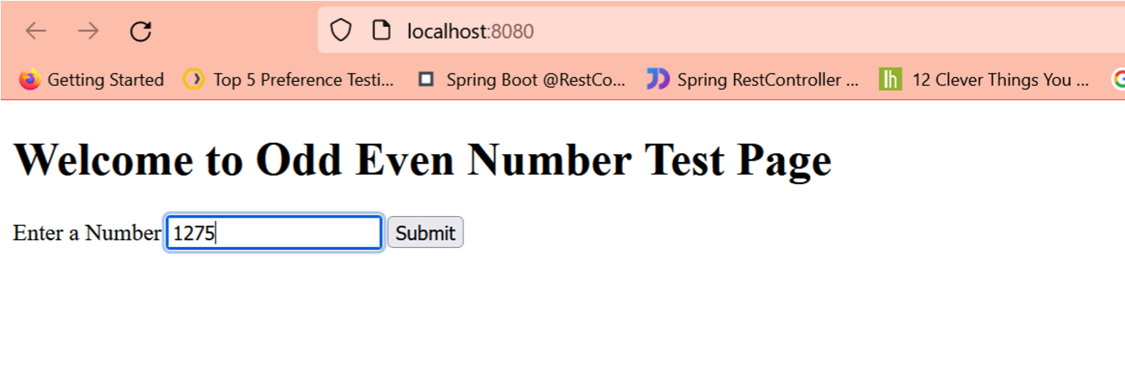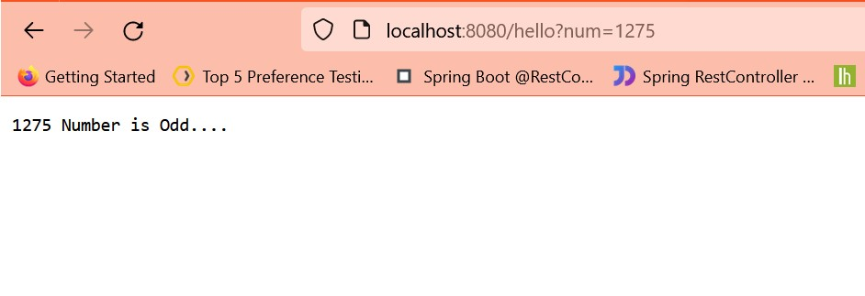

2. Write a java program using Google App Engine for checking entered number is Prime or not.

# Project Explorer is as follows –

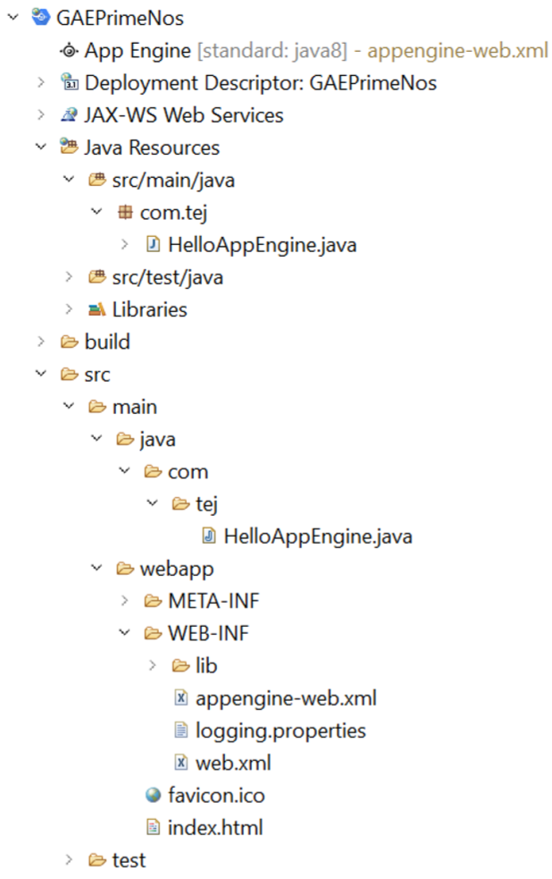

# Code for index.html –

<!DOCTYPE html>

<html xmlns=*"http://www.w3.org/1999/xhtml"* lang=*"en"*>

<head>

<meta http-equiv=*"content-type"* content=*"application/xhtml+xml; charset=UTF-8"* />

<title>Hello App Engine</title>

</head>

<body>

<h1>App Engine Program for Checking number is Prime Number or not.</h1>

<form method=*"get"* action=*"/hello"*> Enter a Number: <input type=*"text"* name=*"numTxt"*>

<p></p>

<button>Submit</button>

</form>

</body>

</html>

# Code for HelloAppEngine.java – package com.tej;

import java.io.IOException; import java.io.PrintWriter; import javax.servlet.annotation.WebServlet; import javax.servlet.http.HttpServlet; import javax.servlet.http.HttpServletRequest; import javax.servlet.http.HttpServletResponse;

@WebServlet( name = "HelloAppEngine", urlPatterns = {"/hello"} ) public class HelloAppEngine extends HttpServlet { private static final long serialVersionUID = 1L;

@Override public void doGet(HttpServletRequest request, HttpServletResponse response) throws IOException {

response.setContentType("text/plain"); response.setCharacterEncoding("UTF-8"); PrintWriter out = response.getWriter();

boolean flag = true;

String txtParam = request.getParameter("numTxt"); out.println("Number is: " + txtParam); int num = Integer.parseInt(txtParam); for(int i=2; i<Math.sqrt(num); i++) { if(num%i == 0) { flag = false; break;

} }

if(flag == true) out.println(num + " is Prime no."); else out.println(num + " is NOT Prime no.");

}

}

# Output of the Program –

